Morphologic Diagnosis of Inflammation

Exudative Inflammation

An exudate is a fluid emitted by an organism through pores or a wound, a process known as exuding.[1] Exudate is derived from exude, "to ooze,"[2] from the Latin exsūdāre, "to (ooze) out like sweat" (ex- "out" and sūdāre "to sweat"). An exudate is any fluid that filters from the circulatory system into lesions or areas of inflammation. It can be a pus-like or clear fluid. When an injury occurs, leaving skin exposed, it leaks out of the blood vessels and into nearby tissues. The fluid is composed of serum, fibrin, and white blood cells. Exudate may ooze from cuts or from areas of infection or inflammation.
- Purulent or suppurative exudate consists of plasma with both active and dead neutrophils, fibrinogen, and necrotic parenchymal cells (dying cells of a specific Gland or organ). This kind of exudate is consistent with more severe infections, and is commonly referred to as pus.
- Fibrinous exudate is composed mainly of fibrinogen and fibrin. It is characteristic of rheumatic carditis, but is seen in all severe injuries such as strep throat and bacterial pneumonia. Fibrinous inflammation is often difficult to resolve due to blood vessels growing into the exudate and filling space that was occupied by fibrin. Often, large amounts of antibiotics are necessary for resolution.
- Catarrhal exudate is seen in the nose and throat and is characterized by a high content of mucus.
- Serous exudate (sometimes classified as serous transudate) is usually seen in mild inflammation, with relatively low protein.^{[9]} Its consistency resembles that of serum, and can usually be seen in certain disease states like tuberculosis.

Serous exudate

This is a very mild form of inflammation and may indicate a minor injury, or it may be the start of something more serious. (In general, SEROUS is NOT SERIOUS!). Serous fluid is what accumulates inside a blister. Also, it is the clear yellow material that comes out of a minor skin wound.
The most common places to find serous exudate is on the skin surface ("hot spot" in flea allergy dermatitis) or in a body cavity, or in your nose!
In general serous exudates results when inflammatory mediators create endothelial gaps large enough for fluid and some protein to leak out. More severe capillary damage would result in either fibrin or red blood cells being mixed within the fluid. By definition there are few leukocytes in this exudate.
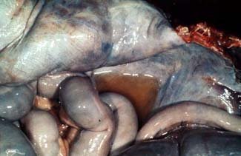 | This horse had abdominal surgery and died two days later of another cause.  Because of the manipulation of the intestines at surgery, there was an outpouring of serous fluid into the abdomen, resulting in a "serous peritonitis."

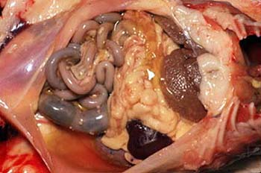
This is from a postmortem on a cat. There is excess yellow fluid in the abdomen - this is a serous peritonitis. This cat had feline infectious peritonitis.
In this case, knowing the disease, it can be safely stated that this mild serous peritonitis was a harbinger of worse things to come.
Fibrinous exudate
In serous exudation, just very small molecules of protein get out of the blood stream and into the tissue. With fibrinous exudation, the vascular insult is more severe, and larger holes develop, allowing fibrinogen to get out into the tissue as well. When fibrinogen reaches tissue, it turns into fibrin. Fibrinous exudation is always an indication of an more severe insult.
Don't confuse the adjective fibrinous (means fibrin in the exudate) with fibrous (is not a modifier of an exudate and means composed of fibrous connective tissue).
In the earliest stages, fibrin just appears as a light meshwork, which may have a granular appearance grossly.
The lung is from a sheep in the early stages of infection with Pasteurella multocida, the pleura is responding with an outpouring of fibrin, which forms strands on the surface of the lung.

These strands can be peeled off readily, in contrast to a chronic process where the fibrin becomes organized by fibrous connective tissue and becomes tough and is considerably more adherent.
This is from a cat with feline infectious peritonitis.
Note the granular appearance to the serosa of the intestinal loops - this is due to bits of fibrin.
Also, there is a layer of fibrin over the liver. In some places, there is a distinctly strand-like appearance.

This poor tortoise had an acute stomatitis. Dissection of the oral cavity reveals a layering of fibrin over various parts of the oral cavity.

Purulent exudate
Purulent = suppurative = pus
The essential elements in purulent exudates are neutrophils. Purulent inflammation almost always signifies the presence of bacteria.
This is an opened mammary gland from a cow (teat is at the left). What is the creamy tan material? Yes, it is pus. So, what is your morphologic diagnosis?

Purulent inflammation can have a variety of consistencies.

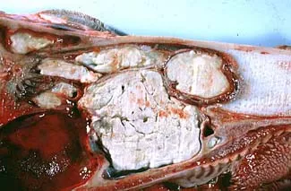 | In this example of purulent sinusitis in a cow, the pus has become thickened and dried. Often, this form of pus is referred to as "inspissated" or "caseous".

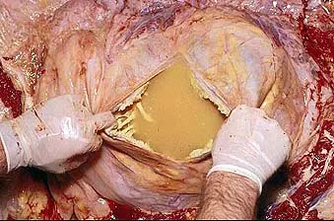 | 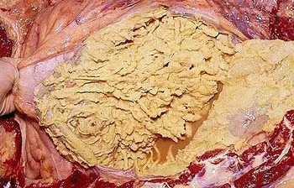

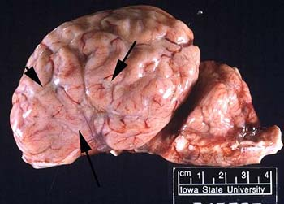 | On the left is the brain of a one-month-old lamb. There is a diffuse purulent meningitis. The arrows are pointing to the purulent exudate found within the sulci.
If the purulent inflammation is well-localized by fibrous tissue, it is referred to as an abscess. Here are some examples:
Purulent exudate is often associated with fibrinous exudate. In the examples to the left of a riproaring pericarditis, both types of exudates are obviously present and we would call this fibrionopurulent pericarditis.
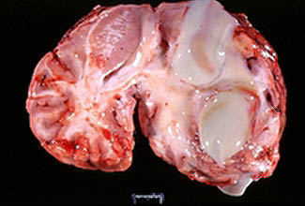 | This foal didn't have much of a chance, with two brain abscesses caused by Streptococcus equi.  The fibrous wall is very thin because the CNS has little capacity to form connective tissue. Had this been in another location, for example the liver, the fibrous capsule would have been more prominent.

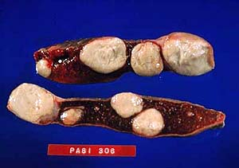 | These multiple abscesses in a sheep spleen were caused by Corynebacterium pseudotuberculosis, the agent of caseous lymphadenitis.  This is a common cause of "wasting ewe syndrome." Not surprising. So many neutrophils around and nonstop production of inflammatory mediators.

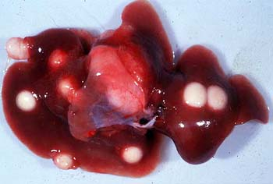 | This is a liver from a guinea pig that was doing poorly for some time prior to death. Yersinia pseudotuberculosis was cultured from the abscesses.
As you have noticed purulent exudate can have different colors. The color can be affected by a number of variables. If blood is in the mix it may be pink. If the bacteria has pigment they can change the color. Necrotic tissue can add color and the neutrophils can give the exudate a white or green appearance.
**After reading this article, write a summary of each type of exudate, composition, cause, and examples of them. Your next lesson will be a continuation of this information.

