The Immune System - in More Detail
Introduction
The immune system is one of nature's more fascinating inventions. With ease, it protects us against billions of bacteria, viruses, and other parasites. Most of us never reflect upon the fact that while we hang out with our friends, watch TV, or go to school, inside our bodies, our immune system is constantly on the alert, attacking at the first sign of an invasion by harmful organisms.
The immune system is very complex. It's made up of several types of cells and proteins that have different jobs to do in fighting foreign invaders. In this section, we'll take a look at the parts of the immune system in some detail. If you're reading about the immune system for the first time, we recommend that you take a look at the Immune System Overview first (see link below).
The Complement System
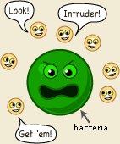
The first part of the immune system that meets invaders such as bacteria is a group of proteins called the complement system. These proteins flow freely in the blood and can quickly reach the site of an invasion where they can react directly with antigens - molecules that the body recognizes as foreign substances. When activated, the complement proteins can
 | - |  | trigger inflammation
 | - |  | attract eater cells such as macrophages to the area
 | - |  | coat intruders so that eater cells are more likely to devour them
 | - |  | kill intruders

Phagocytes
This is a group of immune cells specialized in finding and "eating" bacteria, viruses, and dead or injured body cells. There are three main types, the granulocyte, the macrophage, and the dendritic cell.
Copyright © Nobel Media AB 2016
The granulocytes often take the first stand during an infection. They attack any invaders in large numbers, and "eat" until they die. The pus in an infected wound consists chiefly of dead granulocytes. A small part of the granulocyte community is specialized in attacking larger parasites such as worms.
The macrophages ("big eaters") are slower to respond to invaders than the granulocytes, but they are larger, live longer, and have far greater capacities. Macrophages also play a key part in alerting the rest of the immune system of invaders. Macrophages start out as white blood cells called monocytes. Monocytes that leave the blood stream turn into macrophages.
The dendritic cells are "eater" cells and devour intruders, like the granulocytes and the macrophages. And like the macrophages, the dendritic cells help with the activation of the rest of the immune system. They are also capable of filtering body fluids to clear them of foreign organisms and particles.

Lymphocytes - T cells and B cell
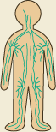 | 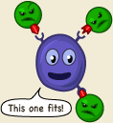
The lymphatic system | The receptors match only one specific antigen.

White blood cells called lymphocytes originate in the bone marrow but migrate to parts of the lymphatic system such as the lymph nodes, spleen, and thymus. There are two main types of lymphatic cells, T cells and B cells. The lymphatic system also involves a transportation system - lymph vessels - for transportation and storage of lymphocyte cells within the body. The lymphatic system feeds cells into the body and filters out dead cells and invading organisms such as bacteria.
On the surface of each lymphatic cell are receptors that enable them to recognize foreign substances. These receptors are very specialized - each can match only one specific antigen.
To understand the receptors, think of a hand that can only grab one specific item. Imagine that your hands could only pick up apples. You would be a true apple-picking champion - but you wouldn't be able to pick up anything else.
Copyright © Nobel Media AB 2016
In your body, each single receptor equals a hand in search of its "apple." The lymphocyte cells travel through your body until they find an antigen of the right size and shape to match their specific receptors. It might seem limiting that the receptors of each lymphocyte cell can only match one specific type of antigen, but the body makes up for this by producing so many different lymphocyte cells that the immune system can recognize nearly all invaders.

T cells
T cells come in two different types, helper cells and killer cells. They are named T cells after the thymus, an organ situated under the breastbone. T cells are produced in the bone marrow and later move to the thymus where they mature.
Helper T cells are the major driving force and the main regulators of the immune defense. Their primary task is to activate B cells and killer T cells. However, the helper T cells themselves must be activated. This happens when a macrophage or dendritic cell, which has eaten an invader, travels to the nearest lymph node to present information about the captured pathogen. The phagocyte displays an antigen fragment from the invader on its own surface, a process called antigen presentation. When the receptor of a helper T cell recognizes the antigen, the T cell is activated. Once activated, helper T cells start to divide and to produce proteins that activate B and T cells as well as other immune cells.

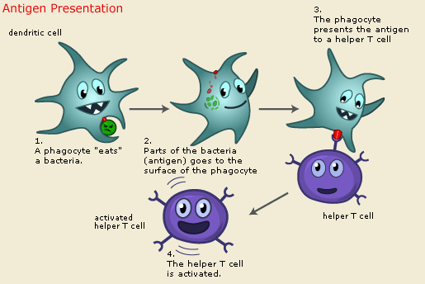
Copyright © Nobel Media AB 2016
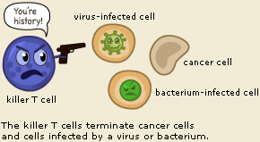 | The killer T cell is specialized in attacking cells of the body infected by viruses and sometimes also by bacteria. It can also attack cancer cells. The killer T cell has receptors that are used to search each cell that it meets. If a cell is infected, it is swiftly killed. Infected cells are recognized because tiny traces of the intruder, antigen, can be found on their surface.

B Cells
The B lymphocyte cell searches for antigen matching its receptors. If it finds such antigen it connects to it, and inside the B cell a triggering signal is set off. The B cell now needs proteins produced by helper T cells to become fully activated. When this happens, the B cell starts to divide to produce clones of itself. During this process, two new cell types are created, plasma cells and B memory cells.
The plasma cell is specialized in producing a specific protein, called an antibody,that will respond to the same antigen that matched the B cell receptor. Antibodies are released from the plasma cell so that they can seek out intruders and help destroy them. Plasma cells produce antibodies at an amazing rate and can release tens of thousands of antibodies per second.
When the Y-shaped antibody finds a matching antigen, it attaches to it. The attached antibodies serve as an appetizing coating for eater cells such as the macrophage. Antibodies also neutralize toxins and incapacitate viruses, preventing them from infecting new cells. Each branch of the Y-shaped antibody can bind to a different antigen, so while one branch binds to an antigen on one cell, the other branch could bind to another cell - in this way pathogens are gathered into larger groups that are easier for phagocyte cells to devour. Bacteria and other pathogens covered with antibodies are also more likely to be attacked by the proteins from the complement system.
The Memory Cells are the second cell type produced by the division of B cells. These cells have a prolonged life span and can thereby "remember" specific intruders. T cells can also produce memory cells with an even longer life span than B memory cells. The second time an intruder tries to invade the body, B and T memory cells help the immune system to activate much faster. The invaders are wiped out before the infected human feels any symptoms. The body has achieved immunity against the invader.

Copyright © Nobel Media AB 2016
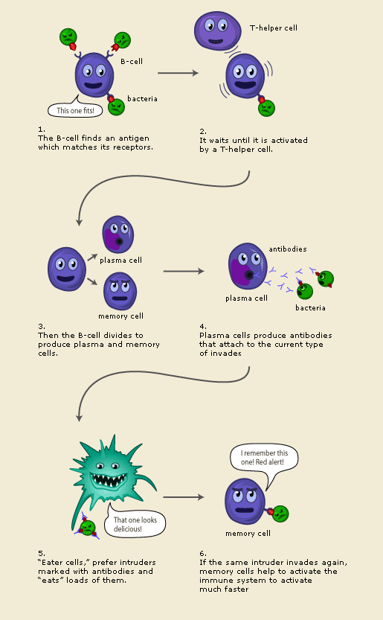

Copyright © Nobel Media AB 2016

