CH. 17
Taxonomy and Classification Notes
Early Systems of Classification
Classification is the grouping of objects or organisms based on a set of criteria.
Biologists use a system of classification to organize information about the diversity of living things.
Linnaeus’s system of classification was based on observations of morphology and habitat.
The Linnaean system was the first formal system of taxonomy – the discipline of identifying, naming, and classifying organisms.
Linnaeus’s method of naming organisms, called binomial nomenclature, gives each species a scientific name with two parts.
The first part is the genus name, and the second part is the specific epithet, or specific name, that identifies the species.
When writing a scientific name, scientists use these rules:
  - The first letter of the genus name always is capitalized, but the rest of the genus name and all letters of the specific epithet are lowercase.
  - For example Crotalus atrox
  - After the scientific name has been written completely, the genus name will be abbreviated to the first letter in later appearances (e.g., C. atrox Western Diamondback rattlesnake).

Taxonomic Categories
The taxonomic categories used by scientists are part of a nested-hierarchal system.
Each category is contained within another, and they are arranged from broadest to most specific.

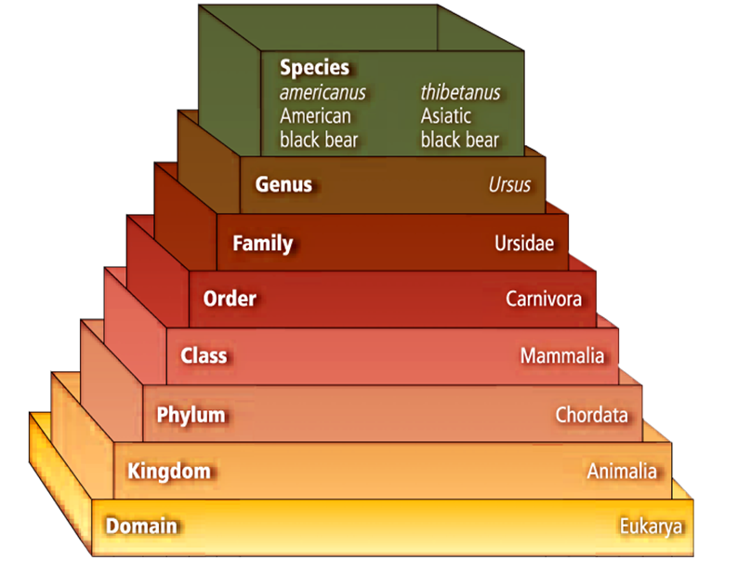

Higher taxa
An order contains related families.
A class contains related orders.
A phylum or division contains related classes.
A kingdom contains related phyla.
The domain is the broadest of all the taxa and contains one or more kingdoms.
A named group of organisms is called a taxon.
A genus is a group of species that are closely related and share a common ancestor.
A family is the next higher taxon, consisting of similar, related genera

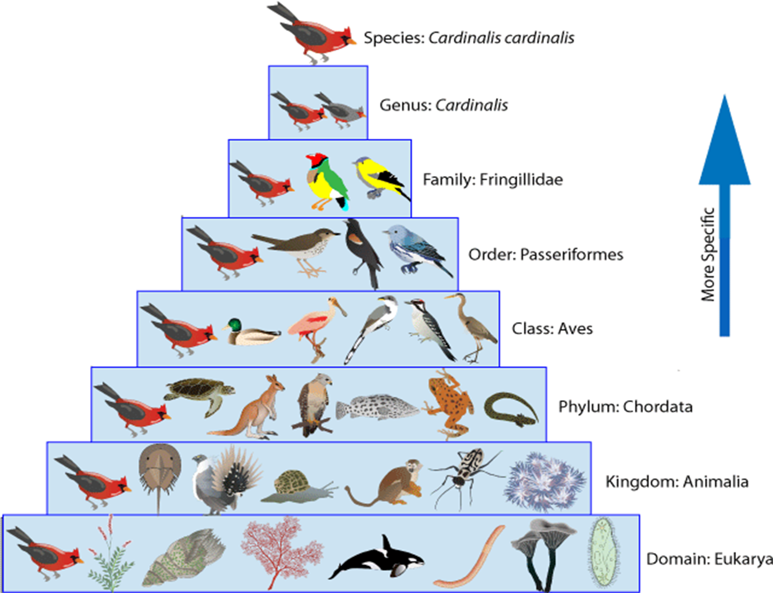
Systematics applications
Taxonomy is part of a larger branch of biology called systematics.
Systematics is the study of biological diversity with an emphasis on evolutionary history.
Taxonomists can produce detailed guides to identify different organisms.
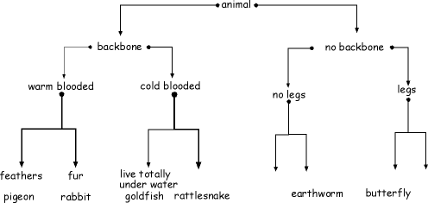
Through the use of dichotomous keys, which provide a series of choices between alternate characteristics, users can identify organisms they encounter.
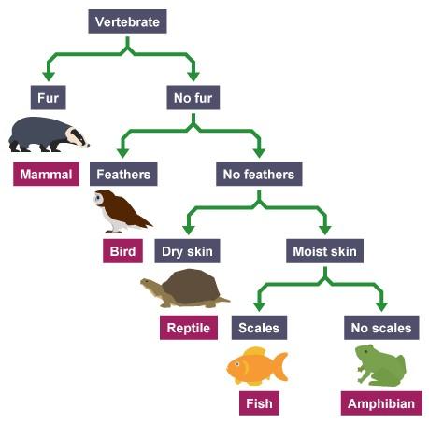
Typological species concept
The concept of what determines a species has changed through time.
Aristotle and Linnaeus used the typological species concept – each species a distinctly different group of organisms based on physical similarities.
Based on the idea that species are unchanging, distinct, and natural types.
Biological species concept
The biological species concept defines a species as a group of organisms that is able to interbreed and produce fertile offspring in a natural setting.
Does not account for extinct species or species that reproduce asexually.

Phylogenic species concept
Phylogeny is the evolutionary history of a species.
The phylogenic species concept defines a species as a cluster of organisms that is distinct from other clusters and shows evidence of a pattern of ancestry and descent.
Characters
To classify a species, scientists construct patterns of descent by using characters – inherited features that vary among species.
Characters can be morphological or biochemical.

Morphological characters
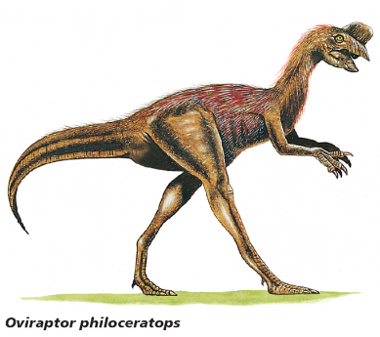
Shared morphological characters suggest that species are related closely and evolved from a recent common ancestor.
Birds and dinosaurs:
  - Modern birds may not look closely related to dinosaurs.
  - Both birds and dinosaurs have hollow bones
  - Theropods have hip, leg, wrist, and shoulder structures more similar to birds than living reptiles.
Biochemical characters
- Scientists use biochemical characters, such as amino acids and nucleotides, to help them determine evolutionary relationships among species.
- DNA and RNA analyses are powerful tools for reconstructing phylogenies.
- DNA or chimpanzee, gorilla, and Orangutan are very similar ---------------

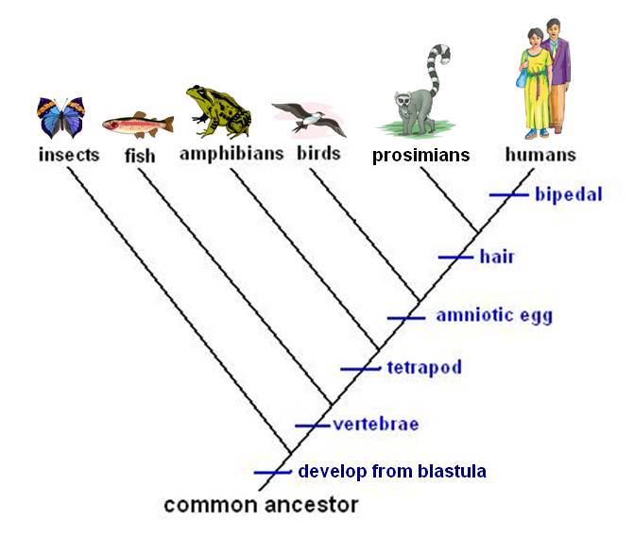
Character types
Cladistics classifies organisms based on the order that they diverged from a common ancestor.
Scientists consider two main types of characters when doing cladistic analyses:
Ancestral characters are found within the entire line of descent of a group of organisms.
Derived characters are only found after a split from the descendent line.
A cladogram is a branching diagram that represents a proposed phylogeny of a species or group.
One branch of a cladogram is called a clade.

The broadest category in the classification used by most biologists is the domain.
  - Three domains: Bacteria, Archaea, Eukarya
  - Six kingdoms: Bacteria, Archaea, Protists, Fungi, Plantae, and Animalia
- Organisms are classified into domains based on cell type and structure
- Organisms are classified into kingdoms based on cell type, structure, and nutrition
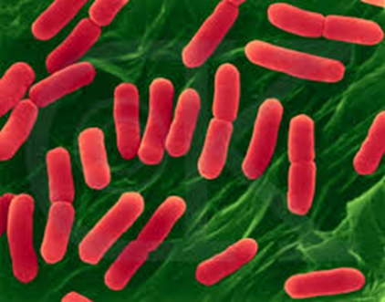
Domain Bacteria
- Bacteria are members of both Domain and Kingdom Bacteria
  - Prokaryotes
  - Cell walls contain peptidoglycan
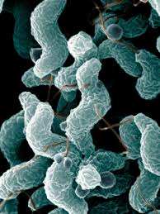
- Diverse group that can survive many different environments
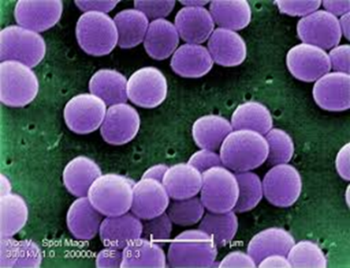
- Most bacteria are heterotrophs that get their energy from other organisms
- Most abundant organism on the planet
Prokaryote Characteristics
Shapes- Cocci (spherical or round), Bacilli (rod-shaped), Spirilli (spiral-shaped)

Movement
Some prokaryotes are stationary, others move with flagella.
Flagella help prokaryotes to move toward materials that they need to survive – light, oxygen, chemicals.
Other prokaryotes move by gliding over a layer of secreted slime

Domain Archaea
- Archaea are thought to be more ancient than bacteria and yet more closely related to our eukaryote ancestors.
- Lack peptidoglycan in their cell walls, and have some of the same proteins as eukaryotes.
- Archaea are diverse in shape and nutrition requirements.
- Most are heterotrophs, some are extremophiles that can survive extreme conditions (e.g. high temperature, salinity)
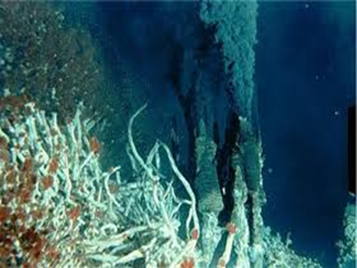
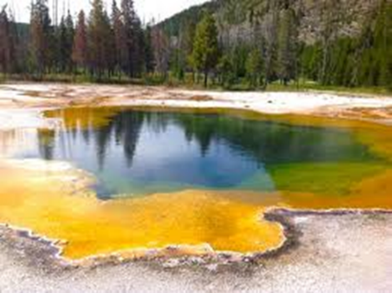
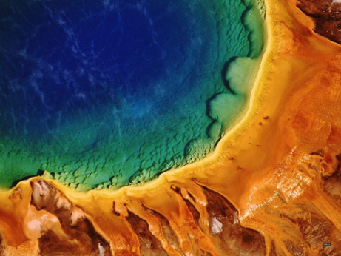

Domain Eukarya
- All eukaryotes have a membrane-bound nucleus and other membrane-bound organelles.
- Domain Eukarya contains Kingdoms Protista, Fungi, Plantae, and Animalia.
Kingdom Protista
- Protists are eukaryotic organisms that can be unicellular, colonial, or multicellular.
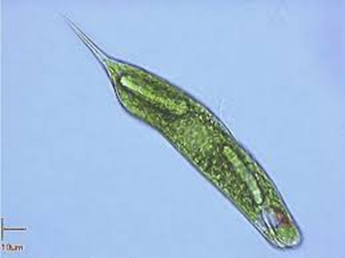
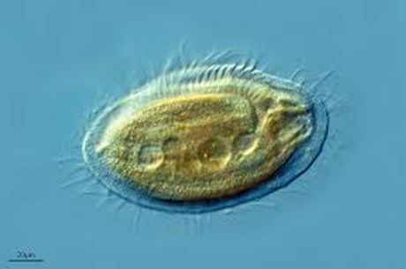
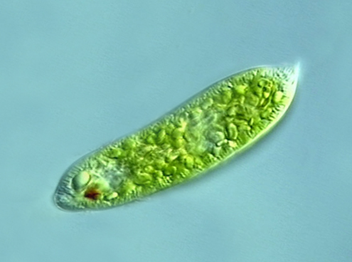
- Protists are classified into three different groups – plantlike, animal-like, and fungus-like.

Kingdom Fungi
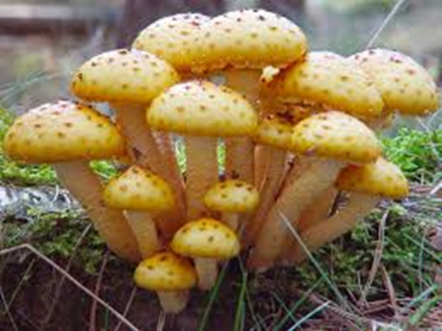
- A fungus is a unicellular or multicellular eukaryote that absorbs nutrients from organic materials in its environment.
- Heterotrophic, lack motility, have cell walls containing chitin.
- Have threadlike structures called hyphae for feeding, growth, and reproduction
Kingdom Animalia – Animals that have cells and tissues, and are mobile.
Kingdom Plantae – mostly multicellular, have cell wall, and chloroplast.
