Tumors: Benign, Premalignant and Malignant Explained
A tumor, also known as a neoplasm, is an abnormal mass of tissue which may be solid or fluid-filled.
A tumor does not mean cancer - tumors can be benign (not cancerous), pre-malignant (pre-cancerous), or malignant (cancerous).
There are many different types of tumors and a variety of names for them - their names usually reflect their shape and the kind of tissue they appear in. Put simply, a tumor is a kind of lump or swelling, it does not necessarily pose a health threat.
When doctors use the term tumor they are talking generically and not about the size of the lesion. A mass usually refers to a lump which is at least 20 mm (0.787 inches) in diameter at its widest point, while a nodule is less than 20 mm at its widest point.
Tumor sizes may vary enormously. In January 2012, Nguyen Duy Hai, a 32-year-old Vietnamese man underwent a 12-hour operation to remove a 200-pound tumor from his leg. Dr. McKay McKinnon, lead surgeon, had rated the success of the operation at just 50%. The surgery was a success.
Cancer stem cells may play a major role in tumor growth, three studies published in the journals Nature and Science revealed in August 2012. Scientists believe cancer might have its own stem cells that impact on the regrowth of tumors. They added that if further studies confirm their findings, the way we treat cancerous tumors may change dramatically.

Benign tumors
A benign tumor (benign neoplasm) cannot metastasize - it cannot spread. Examples include uterine fibroids and moles. "Benign" means it is non-progressive, it remains as it is.
Most benign tumors are not harmful to human health. Even though they are not cancerous, some may press against nerves or blood vessels and cause pain or other negative effects. Benign tumors of endocrine tissues may result in the excessive production of some hormones.
Examples of benign tumors include:

Adenomas
Adenomas are tumors that arise from glandular epithelial tissue - epithelial tissue is the thin membrane that covers glands, organs and other structures in the body. A polyp in the colon is a type of adenoma. Other examples include pituitary adenoma, adrenocortical adenoma, basal cell adenoma, bile duct adenoma, chromophobe adenoma, follicular adenoma, hepatocellular adenoma, and nipple adenoma (there are many more).
Although adenomas are not cancerous, they can change and become so; then they are called adenocarcinomas.

Fibroids (fibromas)
Fibroids (fibromas) are benign tumors that grow on fibrous or connective tissue of any organ in the body. Uterine fibroids are common. Uterine fibroids can cause vaginal bleeding, pelvic pain or discomfort, and urinary incontinence.
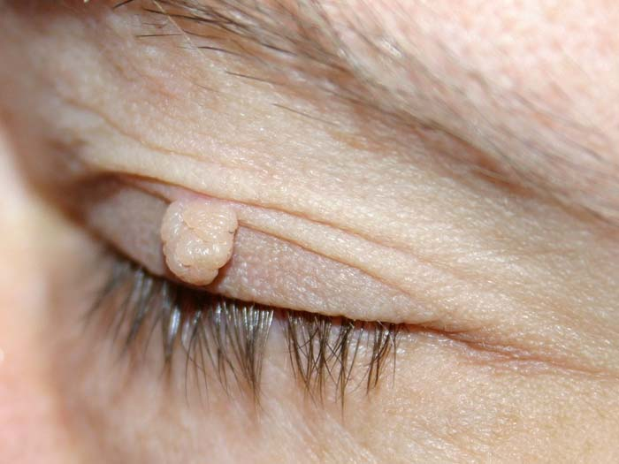
A soft fibroma of the eyelid. Photo credit: Oliver Riesen
The fibroma durum (hard fibroma) is made up of many fibers and few cells. The fibroma molle (soft fibroma) is made up of several loosely connected cells and less fibroid tissue. Soft fibroma is usually found in the armpits, groin, neck and eyelids.
There are many types of fibromas, such as angiofibroma, cystic fibroma (fibroma cysticum), myxofibroma (fibroma myxomatodes), nonossifying fibroma, ossifying fibroma, cemento-ossifying fibroma, pleomorphic fibroma, fibroma of tendon sheath nuchal fibroma, chondromyxoid fibroma, desmoplasmic fibroma, collagenous fibroma, and perifollicular fibroma.
Some fibromas can cause symptoms and may require surgical removal. Rarely, fibroids can change and eventually become cancerous, they are then called fibrosarcomas.

Hemangiomas
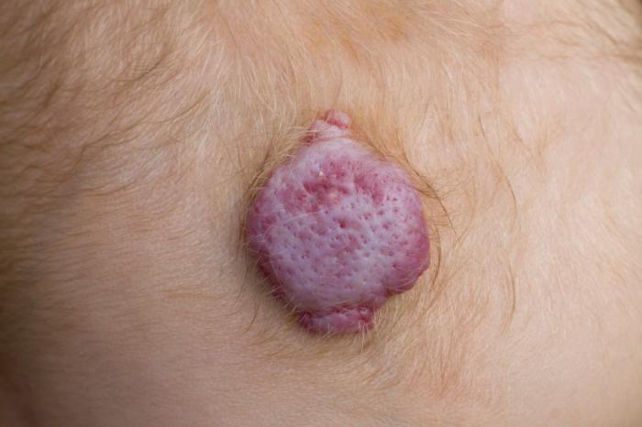
A hemangiomas on the scalp of a child
Hemangiomas are benign tumors which consists of a collection of too many blood cells. They can sometimes be seen on the surface of the skin and are colloquially called strawberry marks. The majority of hemangiomas appear at birth and gradually go away after some months or years.
Hemangiomas do not usually require any treatment. If they affect the patient's ability to eat, hear or see, the doctor may recommend treatment with corticosteroids. If the patient is over 10 years of age, they are more commonly removed today using laser surgery.

Lipomas
Lipomas are the most common form of soft-tissue tumor. Lipomas consist of adipose tissue (fat cells). Most of them are very small, painless, soft to the touch, and generally movable. They are more common among people aged 40+ years. Experts disagree on whether lipomas can change and become cancerous (malignant).
There are many kinds of lipomas, such as angiolipoleiomyoma, angiolipoma, chondroid lipoma, corpus callosum lipoma, hibernoma, intradermal spindle cell lipoma, neural fibrolipoma, pleomorphic lipomas, and superficial subcutaneous lipoma (the most common type, found just below the skin's surface).

Premalignant tumors
A premalignant or precancerous tumor is one that is not yet malignant, but is about to become so.
Examples of premalignant growths include:
- Actinic keratosis - also known as senile keratosis or solar keratosis is a premalignant growth consisting of crusty, scaly and thick patches of skin. Fair-skinned people are more susceptible to these types of growths, especially those who are exposed to sunlight (it is linked to solar damage).
Actinic keratoses are seen as potentially premalignant because a number of them progress to squamous cellcarcinoma. Doctors usually recommend treating them because of this. There is a 20% risk that untreated lesions eventually become cancerous. Continuous sun exposure increases the risk of malignancy.
- Dysplasia of the cervix - the normal cells lining the cervix of the uterus change. The growth can be premalignant, a prelude to cervical cancer. Cervical dysplasia is diagnosed with a PAP smear. According to the National Institutes of Health, USA, about 5% of PAP smears detect the presence of cervical dysplasia. They are more common in women aged 25 to 35. They may be removed with Cryotherapy (freezing), or conization (the cone of tissue from the cervix is removed).
- Metaplasia of the lung - the growths occur in the bronchi, tubes that carry air from the windpipe into the lung. The bronchi are lined with glandular cells, which can change and become squamous cells. Metaplasia of the lung is most commonly caused by smoking.
- Leukoplakia - thick, white patches form on the gums, bottom of the mouth, insides of the cheeks, and less commonly on the tongue. They cannot be scraped off easily. Experts believe tobacco smoking and/or chewing is the main cause. Although Leukoplakia is rarely dangerous, a small percentage are premalignant and can eventually become cancerous. Many mouth cancers occur next to areas of leukoplakia.
If smokers quit, the condition usually clears up. Quitting both alcohol and tobacco together has better results. The patches can be removed using laser, a scalpel or a cold probe that freezes the cancer cells (cryoprobe).

Malignant tumors
Malignant tumors are cancerous tumors, they tend to become progressively worse, and can potentially result in death. Unlike benign tumors, malignant ones grow fast, they are ambitious, they seek out new territory, and they spread (metastasize).
The abnormal cells that form a malignant tumor multiply at a faster rate. Experts say that there is no clear dividing line between cancerous, precancerous and non-cancerous tumors - sometimes determining which is which may be arbitrary, especially if the tumor is in the middle of the spectrum. Some benign tumors eventually become premalignant, and then malignant.
Metastasis - malignant tumors invade nearby cells, and then the cells near those, and spread. Some cells can break off from the tumor and spread to various parts of the body through the bloodstream or the lymphatic system, and establish themselves anywhere in the body, and form new malignant tumors. Metastasis is the process by which cancer cells spread from their primary site to distant locations in the human body. For example, a patient may have started off with melanoma (skin cancer) which metastasized in their brain.
The cancer cells that metastasize are the same as the original ones. If a lung cancer spreads to the liver, those cancer cells that grow in the liver are lung cancer cells which have acquired the ability to invade other organs.
There are different types of tumors, which are made up of specific types of cancer cells:
- Carcinoma - these tumors are derived from the skin or tissues that line body organs (epithelial cells). Carcinomas can be, for example, of the stomach, prostate, pancreas, lung, liver, colon or breast. Many of the most common tumors are of this type, especially among older patients.
- Sarcoma - these are tumors that start off in connective tissue, such as cartilage, bones, fat and nerves. They originate in the mesenchymal cells outside the bone marrow. The majority of sarcoma tumors are malignant. They are called after the cell, tissue or structure they arise from, for example fibrosarcoma, liposarcoma, angiosarcoma, chondrosarcoma, and osteosarcoma.
- Lymphoma/Leukemia - cancer arises from the blood forming (hematopoietic) cells that originate in the marrow and generally mature in the blood or lymph nodes. Leukemia accounts for 30% of childhood cancers. Leukemia is thought to be the only cancer where tumors are not formed.
- Germ cell tumor - these are tumors that arise from a germ cell, pluripotent cells (cells than can turn into any kind of cell). Germ cell tumors most commonly present in the ovary (dysgerminoma) or testicle (seminoma). The majority of testicular tumors are germ cell ones. Less commonly, germ cell tumors may also appear in the brain, abdomen or chest.
- Blastoma - tumors derived from embryonic tissue or immature "precursor" cells. These types of tumors are more common in children than adults. "Blastoma" is often the root word used in longer ones that describe tumors, for example, medulloblastoma and glioblastoma are kinds of brain tumors, retinoblastoma is a tumor in the retina of the eye, osteoblastoma is a type of bone tumor, while a neuroblastoma is a tumor found in children of neural origin.

Tumors: Benign, Premalignant and Malignant Explained

The naming of tumors and cancers
Cancer words usually have a prefix (start of the word) which describes which part of the body is involved, while the suffix (end of the word) tells you what type of cancer it is.
For example, the prefix adeno refers to a gland, from which you get full words like adenosarcoma or adenocarcinoma.
Below are some common prefixes used in cancer terms:
- Uro- (bladder)
- Retino- (eye)
- Osteo- (bone)
- Neuro- (brain)
- Myo- (muscle)
- Myelo- (bone marrow)
- Melano- (pigment cell)
- Lympho- (white blood cell)
- Lipo- (fat)
- Hepato- (liver)
- Hemangio- (blood vessels)
- Erythro- (red blood cell)
- Chondro- (cartilage)
- Adeno- (gland).
Possible suffixes that can be added to the prefixes above are sarcoma, carcinoma, or blastoma.
Written by Christian Nordqvist

