Name: ___________________________ Date: _____________________ Per: ________________

Student Journal

DNA Extraction Lab

1. Where is DNA located in the eukaryotic cell? Prokaryotic cell?

2. What is an extraction buffer, and why did you use it for this lab?

3. What is the function of each substance used during the lab? Complete the table below with your answer.

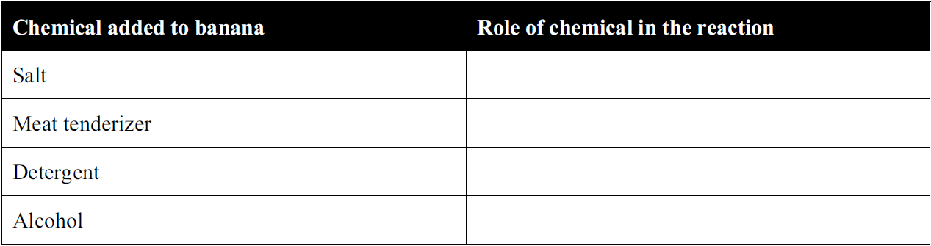

4. Would you expect a sample of human DNA to look exactly like a sample of strawberry DNA? Why?

5. So, if the DNA molecules in human cells is the same as the DNA molecules in all other organisms, what does this say about our relationship to all other living things?

6.

