In evolutionary biology, convergent evolution is the process whereby organisms not closely related (not monophyletic), independently evolve similar traits as a result of having to adapt to similar environments or ecological niches.
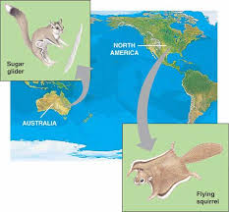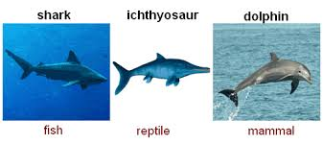
Divergent evolution is the accumulation of differences between groups which can lead to the formation of new species, usually a result of diffusion of the same species to different and isolated environments which blocks the gene flow among the distinct populations allowing differentiated fixation of characteristics
