9 Weeks Final Exam Review
1 A person infected with the human immunodeficiency virus (HIV) may not have any symptoms for a period of time. During this period how does the virus affect the body?

2 Health-care workers are exposed to many different types of pathogenic and nonpathogenic microorganisms. Which body systems work together to protect the body from pathogens?

3 A student sets up a compost bin outdoors. Inside the bin microorganisms convert the student’s vegetable and paper scraps into rich fertilizer. How would you best describes the role that these microorganisms play in natural habitats?

4 Explain the process of energy conversion that takes place in the mitochondria.
5 Most plants have hair-like cells called trichomes that project from the surface and help the plants in many ways. In some plants trichomes secrete toxic substances that most likely perform which function?

6 Plant hormones serve as chemical messengers between cells and tissues. Auxin is a plant hormone that causes the cells on the shady side of a plant shoot to elongate. The response enabled by auxin is known as —

7 Dead zones are low-oxygen areas that develop on the seafloor. Scientists hypothesize that phytoplankton blooms cause these dead zones. Phytoplankton blooms occur when excess nutrients are introduced by pollution from fertilizers, sewage plants, and the burning of fossil fuels. What could likely cause an increase in these dead zones?

8 The human digestive system is approximately 900 cm long. Food is moved through the digestive tract primarily by –
9 Carbohydrates are more easily metabolized than lipids. However, on a gram-for-gram basis which of the two provides the cell with the most energy or calories?

10 Texas suffered an intense drought during the summer and fall of 2011. The drought caused water levels in natural and artificial lakes to drop. Bacteria grew in many of the oxygen- poor lakes, causing the level of oxygen in the lakes to drop further. This led to the death of many fish. What are the vital resources in this scenario?

11 Enzymes are proteins that help increase the rate of chemical reactions inside cells. These proteins are composed of many simpler molecules called amino acids. What would suggest that the shape of an enzyme determines the enzyme’s function?

12 What would most likely cause an increase in the number of anaerobic bacteria in a pond?
13 The carbon cycle includes processes that release carbon into the atmosphere and places that act as carbon reservoirs. The diagram below shows both major processes that release carbon and major carbon reservoirs.

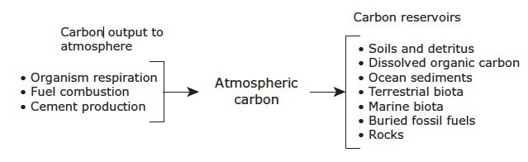
Understand this diagram and how each of the items or activities above can affect the atmosphere and the environment.

14

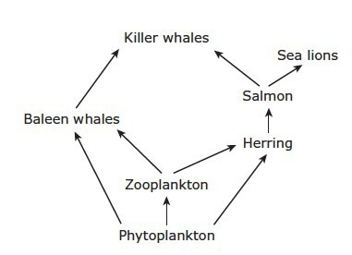

Which group of organisms is missing from the food web shown above?

