2nd 9 Weeks Common Assessment
- A scientist treats an animal cell with a chemical that destroys the cell's mitochondria. As a result of his action, which of the cell's processes will most likely be stopped?

- How does DNA carry information to specify the traits of an organism?

- 5’ TTAGCG 3’
What is the nucleotide base sequences that complements the section of DNA modeled above?

- During replication, the strands of a double-stranded DNA molecule separate from each other when bonds are broken between which part of the nucleotides?

- During replication, DNA molecules separate into single strands, which are then used to construct two identical strands of DNA, one old and one new. How does this process ensure that both daughter cells are identical?

- In animals, as in plants, the genetic code is encoded in the order of which portion of the DNA?

- The cell cycle is disrupted when a cell that is undergoing mitosis incorrectly interprets a chemical signal to stop dividing. Typically, uncontrolled cell division results. What can uncontrolled cell growth lead to?

- How does the chemical structure of DNA vary between organisms?

- Cells synthesize new molecules of proteins, allow the cells to complete reactions. Explain the process of synthesizing a protein?

- Mutated DNA sequences that can be passed from parent to offspring only through which type of cells?

- At warm temperatures, a certain bread mold can often be seen growing on bread as a dark-colored mass. At cooler temperatures, the same bread mold can often be seen growing as a red mass. Write a statement that would best describe why this change in the color of the bread mold occurs?

- What is the role of DNA in cellular differentiation?

- A boy inherits genes that would ordinarily allow him to grow to be tall. His growth is stunted as a result of poor nutrition. Explain why this would occur?

- A cell synthesizes new molecules through protein synthesis. What are the steps of protein synthesis, and where do each of these steps occur?

Use the diagram and your knowledge of science to answer any questions that follow.
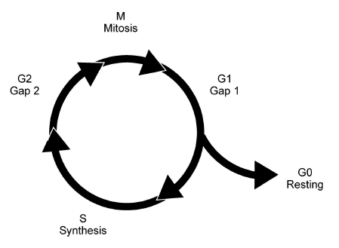
1 5 A disruption of the cell cycle can occur during Gap 1 ("G1" phase). At this phase, a cell may be prevented from synthesizing necessary proteins. What could a failure to synthesize the proteins cause?

