1st Nine Weeks review

1. Surtsey is an island located south of Iceland. The Island was formed by a volcanic eruption and first appeared in 1963. The table below contains descriptions of changes in the population and diversity of species on Surtsey.
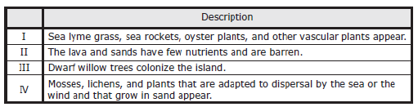
Lists the descriptions in the correct order of ecological succession on Surtsey.

2. Ions form when ___________________________________

3. A chemical reaction is a process by which atoms or groups of atoms in substance are _____________

4. In any environment or ecosystem, organisms can have several different types of relationships. Three of the relationships are described below.
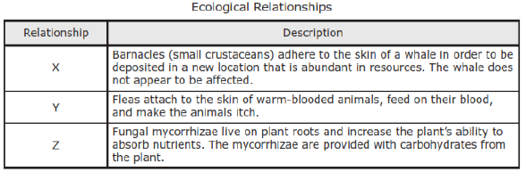
Correctly describes the relationships between the organisms

5. The acacia ant (Pseudomyrmex ferruginea) lives in the bullshorn acacia plant, as shown below.
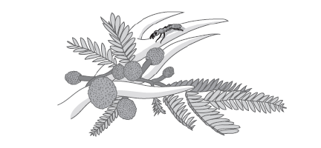
The acacia ant nests and feeds in the plant’s hollow thorns. The ant helps protect the bullshorn acacia by attacking insects and grazing animals that come near the plant. The relationship between the acacia ant and the bullshorn acacia is an example of which of what symbiotic relationship?

6. A Marine ecosystem is represented below
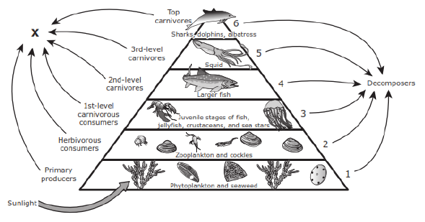
What is lost to the environment at each of the trophic levels in this ecosystem

7. Which is a covalent bond?

8. Elements are placed into the same period on the periodic table of the elements because they _______________________________________________

9. Which macromolecule is involved in nearly every function in the human body?

10. Which macromolecule stores energy for an animal? _____________________________

11. Which of the following diagrams represents an amino acid.
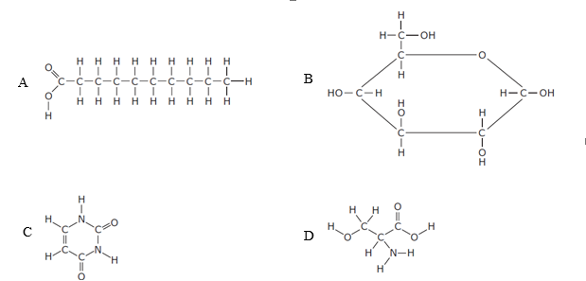
12. Pepsin and trypsin are two of the digestive enzymes that break down protein. A group of students studied the pH requirements of these enzymes. The graph below shows the results.
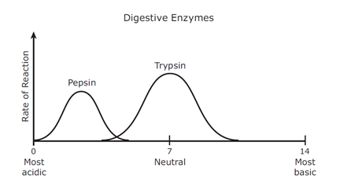
The students found that pepsin functions best in an acid environment and trypsin functions best in a neutral environment. Based on their observations, pepsin most likely aids in digestion in which part of the human body?

13. Lactose is found in milk products. It is converted by the body into a usable form in a series of chemical reactions. The diagram shows the series of reactions that convert lactose into a usable form.
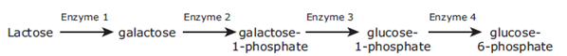
If all the enzymes work properly, but lactose is not ingested by the organism, what would be the outcome?

14. Which of the following biomolecules contains carbon, hydrogen, and oxygen in a 1:2:1 ratio, respectively?

15. As ecosystems move through the stages of succession, the populations of organisms in them change. Which stage of succession likely to have the most species diversity?

16. What are the 3 principals of the Cell Theory?

17. A ________________________ contains polar and nonpolar ends, forming the plasma membrane.

18. Vesicles that digest worn-out organelles or food particles are called _______________________.

19. Which group of organelles is directly responsible for the production of new molecules within a cell?

20. The diagrams show the flow of organic molecules through an ecosystem. One process that occurs in this ecosystem is labeled X, and another process that occurs is labeled Y.
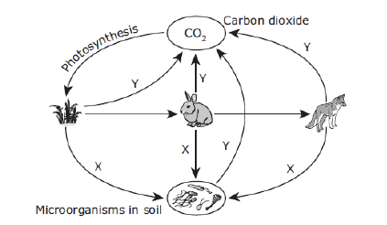
What are the two processes are identified by the labels X and Y?

21. Enzymes are proteins that help increase the rate of chemical reactions inside cells. These proteins are composed of many simpler molecules called amino acids. What suggests that the shape of an enzyme determines the enzyme’s function?

22. Some students used information they gathered from lab investigations to prepare a table. They entered the table in their lab notebooks.
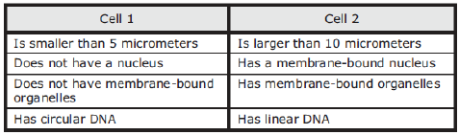
Identify the two cells described in the table.

23. The food web shows the flow of energy through a sagebrush-steppe ecosystem.
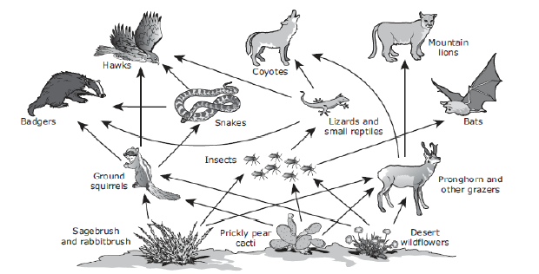
Which of these organisms are in a trophic level that receives a larger percentage of energy captured by the producers than the percentage received at the bats’ trophic level?

24. Which process of energy conversion takes place in the mitochondria?

25. Which cellular process takes place in the ribosomes that are bound to the endoplasmic reticulum?

